Задания для дистанционного обучения по английскому языку на
15.05.2020 г.
____________________________________________________________
Преподаватель: Бондарева Е.А.
Почта: elen.bondarevva@yandex.ru
__________________________________________________________________
Здравствуйте, уважаемые обучающиеся, как Вы знаете на время сложной эпидемиологической обстановки, наш техникум перешел на дистанционное обучение, в связи с этим отправляю Вам задания для самостоятельного изучения.
Порядок выполнения:
- Задания выполняются в рабочей тетради обучающегося.
- На период дистанционного обучения выполненную работу
необходимо отправить на электронную почту: Elen.bondarevva@yandex.ru
- В теме письма необходимо указать ФИО и № группы.

Практическое занятие № 87 по теме:
Достопримечательности Эдинбурга.
Цель: работа над лексикой по теме «Достопримечательности Эдинбурга», совершенствование навыков чтения, говорения.
Задание № 1 . Прочитайте текст.
Scotland is a country in the United Kingdom to the north of England. Its symbol is a thistle; its patron is St. Andrew. The country is divided into Highlands and Lowlands. Most of the industry is concentrated in Lowlands, in the Clyde Valley. Glasgow is its largest and busiest town; Edinburgh is its capital. Glasgow and Edinburgh are two great centres of Scotland. There are only 45 miles between them, and it will take you an hour to get from Glasgow to Edinburgh by train but the cities are very different. Glasgow is the heart of industry. It is a centre of business and trade. It is very busy, prosperous, dirty in some parts and smart in others. Edinburgh is rather cold but attractive.
Edinburgh is known as Athens of the North. If you walk around the city you can touch on history at every step. Practically every building has a tale to tell. The two most interesting parts of the city are the Old Town and the New Town. The Old Town lies between the Castle and Holyrood Palace. The Castle, in fact, is older than the city. No one can exactly say when the first settlers came to on the huge rock that stands high above Edinburgh. Later they built here a castle. It looks beautiful in any weather but at night when it is floodlit it looks just like a castle in a fairy-tale. It is not surprising that the Castle attracts a lot of tourists.
The Edinburgh military tattoo takes place every August and September. For 90 minutes on five or six nights a week, 600 people perform in the square in front of the Castle. One of the most modest and yet one of the best known monuments in Edinburgh is a monument to dog called Bobby. The dog belonged to John Gray. When he died Bobby lived near his grave for twenty-six years. Later Bobby was buried near his master and his statue in the Old Town has become a symbol of devotion. The Old Town is a striking contrast to New Town with its white and beautiful streets. Princes Street is the most beautiful street of the New Town. It is Edinburgh's popular shopping centre. Princess Street lies between the New Town and the Old Town. The modern town is on the lower side, the old one – on the higher. They look at each other across the valley under Scotland's blue sky.
Задание № 2. Ответьте на вопросы к тексту.
- What is Edinburgh sometimes called?
- Where does the Old Town lie?
- What did the Castle use to be?
- Why does the Castle attract many tourists?
- What takes place every August and September?
- What is the Edinburgh military tattoo?
- What is the Royal Mile?
- What monument is the best known in Edinburgh?
Задание № 3. Соотнесите достопримечательности с их описанием.
1. The Edinburgh military tattoo | a) is a royal palace.
2. The Royal Mile | b) is a symbol of devotion.
3. The Cannongate | c) is a show that takes place 5 or 6 nights a week in August and September.
4. Princes Street | d) is known as the Athens of the North.
5. Holyrood House | e) is the most picturesque part of the Royal Mile.
6. The Castle | f) is connected with the name of Walter Scott.
7. Edinburgh | g) is a line of streets that connects the Castle and Holyrood House.
8. The monument to the dog Bobby | h) is the oldest part of Edinburgh.

Приложение № 1
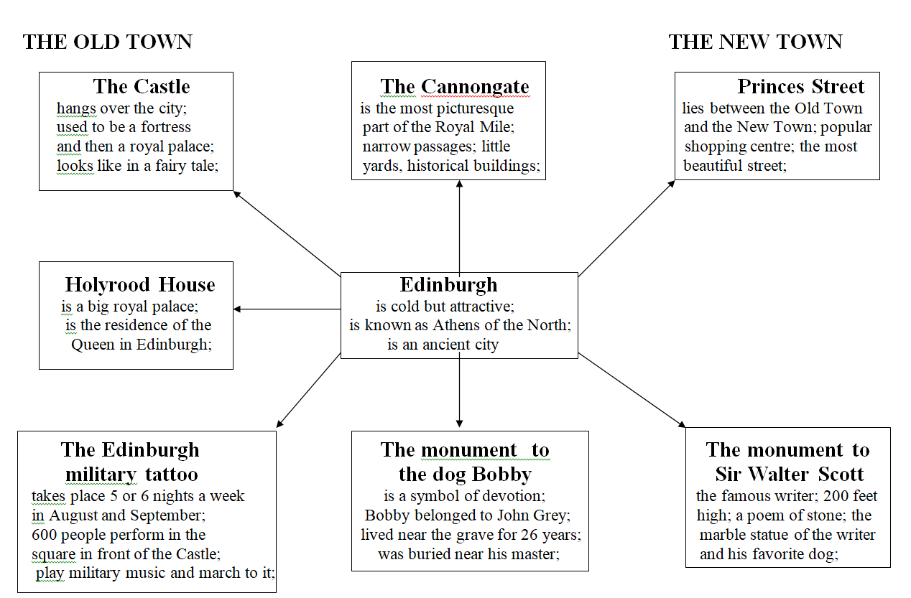
Практическое занятие № 88 по теме:
Достопримечательности Лондона.
Цель: совершенствование разговорных навыков по теме в монологической и диалогической речи.
Задание №1. Фонетическая зарядка.
Работа над произношением слов по изучаемой теме.
[æ] – travel, capital, gallery;
[ei] – play, place, stadium;
[ju:] - museum, new, beautiful;
[i]- big, pig, different;
[a:] – park, car, partner;
[i:] – see, meet, week
Задание № 2. Прочитайте текст.
London
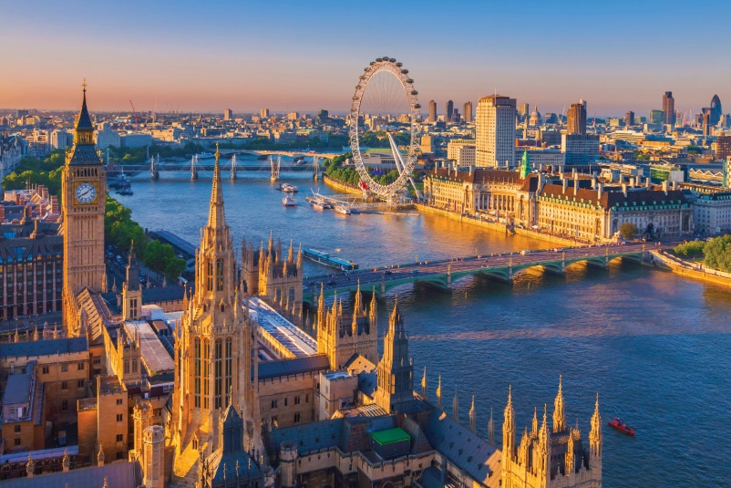
London, is the capital of Great Britain. It's a very big city. London is situated on the river Thames. The Thames is the deepest river in Britain. There are 27 bridges over the Thames. Tower Bridge is one of the oldest and most beautiful bridges in London. It is more than 100 years. About 9 ml people live in London.
London is one of the most beautiful cities in the world. It is also a very old city. London is 2000 years old. London consists of 3 main parts: the City, the West End and the East End. The City is the Heart of London, it's business centre. There are many banks and offices there. The West End is the richest part of London. The main interesting places are situated there. And the East End is a working part of London.
The political centre is Westminster. Westminster Abbey is there. It is the traditional place of coronation for English monarchs. Many people are buried in the church.
There are many sights in London. Trafalgar Square is the most popular place for people to meet. In the middle of the square there is Nelson's Column, which is 51 m. high.
The Queen of England lives in Buckingham palace. It is the most famous place in London.There are 600 rooms in it. It has an indoor swimming pool and a cinema.
One of the greatest English churches, St. Paul's Cathedral , is not far from the Tower of London. The famous English architect Sir Christopher Wren built it in the 17th century after the Great Fire. It is a beautiful building with many columns and towers. It is a royal church.
The most interesting museum is the Tower of London. The Tower of London was a fortress, a palace, a prison and the King’s Zoo. Now it’s a museum. There are always black ravens in the Tower of London. People believe that London will be rich while the ravens live there.
Задание № 3. Ответьте на вопросы.
- What is the capital of England?
- What is the population of London?
- What river does London stand on?
- What places of interest of London do you know?
- Where is the home of the queen of Britain?
- What is Big Ben?
- What is Westminster Abbey?
- What can you see from the Tower Bridge?
Домашнее задание
Homework
Подготовить презентацию о любой достопримечательности Лондона.

